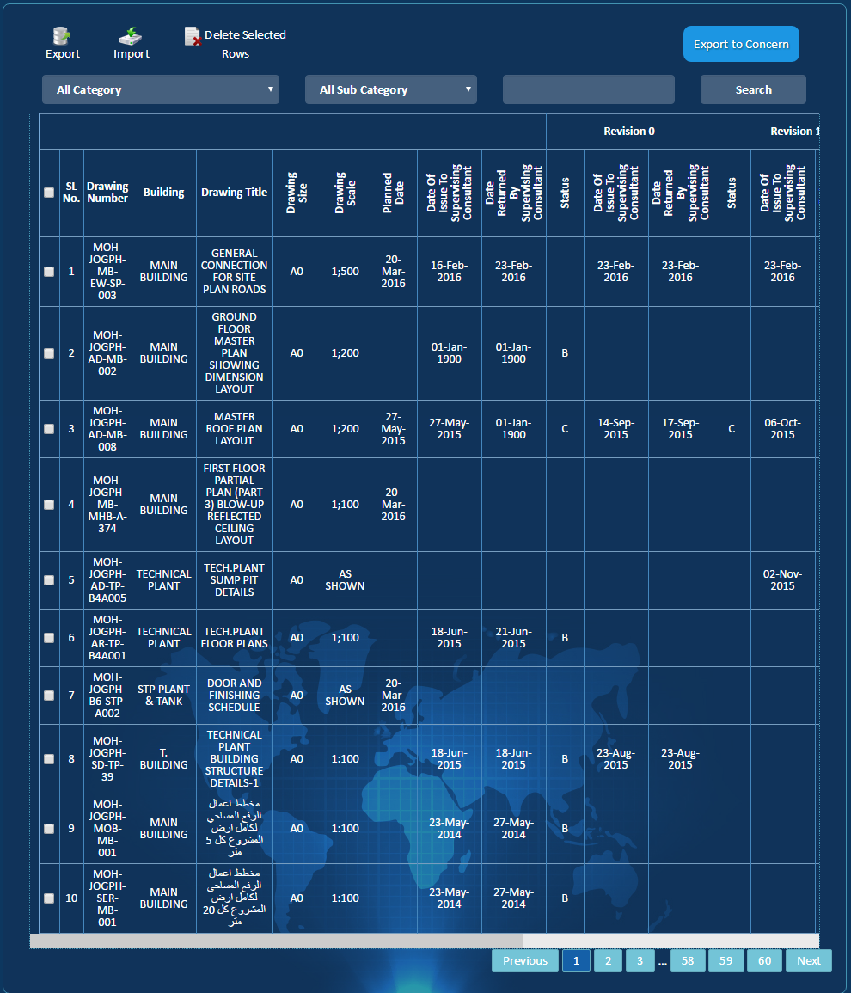

Assigned to User

1.Awaiting Response.2.Responded.3. Draft

Transmittal Letter

Pop-up will Come to show the List of linked Reports

Two options either to add manually or to Import from Excel sheet

Line Item Highlighted if Delayed

Show Links

To be added to the workflow

Tick to Filter Status

To & From Excel

Search by DWG # or Title

**D**

**C**

**B**

**A**

Filter

Tick for delete or Concerns

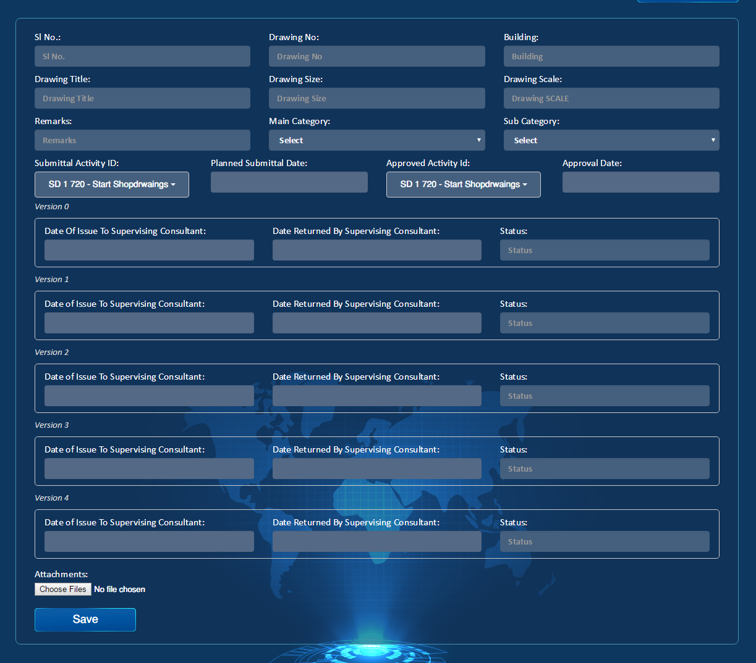

Reject

Approve /Comment

/Comment

/Comment

CC’d

Automatic

Automatic

Automatic

Communications between Contractor and consultant

Assigned to

Approve

Re - Submit

Submit

Draft

Manual addition of Drawings

1.Awaiting Response.2.Responded.3. Draft

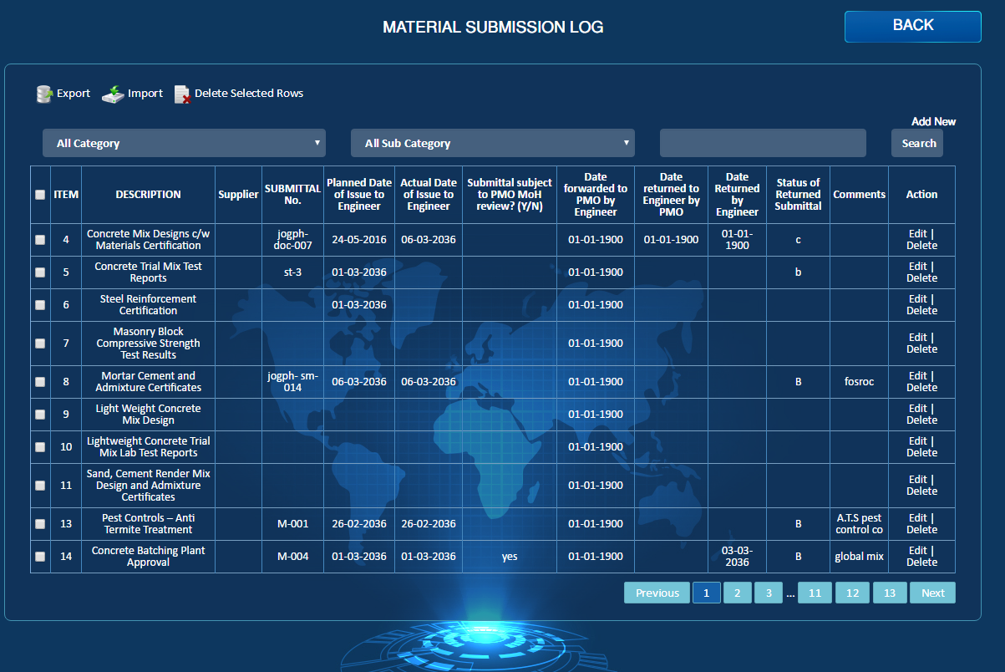

Assigned to User

Show Links

Export to Concerns

**D**

**C**

**B**

**A**

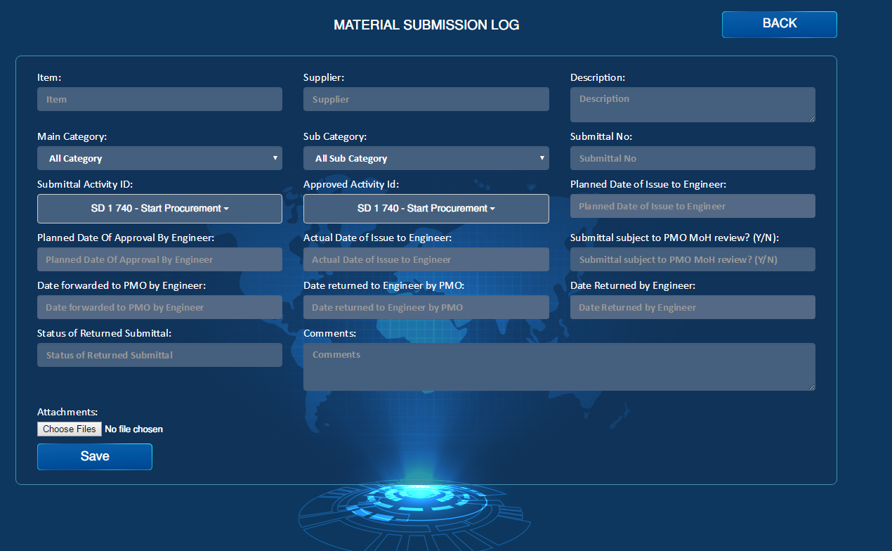

CC’d

Reject

Approve /Comment

Assigned to

Approve

Re - Submit

Submit

Draft

